# Discovers Regions of different Functions (DRoF)

### Segment a city into disjointed regions according to major roads (Road network)

### Infer the functions of each region using a topic-based inference model (POI, check ins)

### Identify the intensity of each function in different locations

### 

# Applications

### Urban planning

### Location choosing for a business

### Social recommendations

# Dataset

### POI datasets of Beijing (in 2010 and 2011)

### Two 3-months GPS trajectory datasets(12000 taxicabs in Beijing in 2010 and 2011)

# Discovery of region topics

## ||Map segmentation||

### Two models in GIS

##### **Vector-based model** uses geometric primitives such as points, lines and polygons to represent spatial objects referenced by Cartesian coordinates

More powerful for precisely finding shortest-paths, whereas it requires intensive computation when performing topological analysis

##### **Raster-based** model quantizes an area into small discrete grid-cells

More computational efficient and succinct for territorial analysis, but the accuracy is limited by the number of cells used for discretizing the road networks

### Proposed Method

##### 

## ||Topic discovery||

### Preliminary

##### Transition *Tr*

Origin region $Tr.r_{o}$

Leaving time $Tr.t_{L}$

Destination region $Tr.r_{D}$

Arrival time $Tr.t_{A}$

##### Mobility Pattern *M*

Given $Tr=\left(Tr.r_{O},Tr.r_{D},Tr.t_{L},Tr.t_{A}\right)$, get

Leaving mobility Pattern $M_{L}=\left(Tr.r_{O},Tr.r_{D},Tr.t_{L}\right)$

Arriving mobility Pattern $M_{A}=(Tr.r_{O},Tr.r_{D},Tr.t_{A})$

##### Transition cuboids $C$

$C∈R^{R×R×T}$

$C_{L}\left(i,j,k\right)=\left|\left|\left\{M_{L}=\left(x,y,z\right) | x=r_{i},y=r_{j},z=t_{k}\right\}\right|\right|$

$C_{A}\left(i,j,k\right)=\left|\left|\left\{M_{A}=\left(x,y,z\right) | x=r_{i},y=r_{j},z=t_{k}\right\}\right|\right|$

##### Topic model LDA

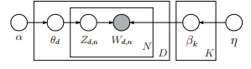

$α,η is the Dirichlet prior$

Number of topics, $K$, Size of vocabulary $V$ and $β$ is a $K×V$ matrix

The topic proportions for the $d^{th}$ document are $θ_{d}$

The topic assignments for the $d^{th}$ document $z_{d}$

$z_{d,n}$ is the assignment for the $n^{th}$ word in the $d^{th}$ document

The observed words for the $d^{th}$ document $w_{d}$

$w_{d,n}$ is the $n^{th}$ word in the $d^{th}$ document

### Topic modeling

##### Correspondence

##### Details

Mobility patterns (words)

$C_{A}\left(1:R,i,,1:T\right)$

$C_{L}(i,1:R,1:T)$ 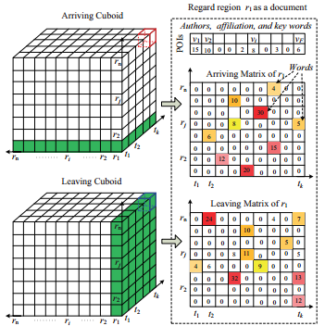

POI vector (metadata)

POI=(name, geo-position)

The frequency density $v_{i}=\frac{Number of the POIs of the i^{th} POI categroy}{Area of region r\left(measured by grid-cells\right)}$

POI featrue vector $x_{r}=\left(v_{1},v_{2},…,v_{F},1\right)$

##### DMR-base topic model

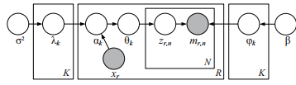

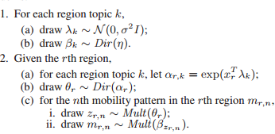

08-Topic models conditioned on arbitrary features with dirichlet-multinomial regression

## ||Territory identification||

### Region Aggreation

##### For each region, given a *K*-dimension vector $θ_{r}=(θ_{r,1},…,θ_{r,K})$

##### Perfrom K-means clustering method

##### Define the number of clusters using the average silhouette value as the criterion

The silhouette value of a point $i$ $s\left(i\right)∈\{-1,1]$

$s\left(i\right)$ appropriately clustered and very distant from its neighboring clusters

$s\left(i\right)$ close to 0 indicates that point is not distinctly in one cluster or another

$s\left(i\right)$ close to -1 means the point is probably assigned to the wrong cluster

perform *m* cross validation on the dataset for different *k* multiple times and choose an appropriate *k* with the maximum overall silhouette value

87-JCAM-Silhouettes: a graphical aid to the interpretation and validation of cluster analysis

##### Aggregate the formal regions into k clusters, each of which is termed as a functional region

### Functionality intensity estimation

##### Estimate the functionality intensity for each aggregated functional region

the functionality of a functional region is generally not uniformly distributed within the entire region

the core functional area may span multiple formal regions and may have an irregular shape

##### Method

feed the origin and destination of each mobility into a KDE(Kernel desinty Estimation) model

number of visits implicitly reflects the popularity of a certain functional region

Given n points $x_{1},x_{2},…,x_{n}$, KDE estimates the intenstiy

$λ\left(s\right)=\sum_{i=1}^{n}{\frac{1}{nr^{2}}K(\frac{d_{i,s}}{r})};K\left(\frac{d_{i,s}}{r}\right)=\frac{1}{\sqrt{2π}}exp⁡(-\frac{d_{i,s}^{2}}{2r^{2}})$

Bandwith *r* is determinded according toMISE criterion

95- Kernel smoothing

## ||Region annotation||

### The POI configuration in a functional region

### The most frequent mobility patterns of each functional region

### The functionality intensity

# Related work

## ||Urban compting with taxicabs||

### study the strategies for improving taxi drivers’ income by analyzing the pick-up and drop-off behavior of taxicabs in different locations

###### 10-KDD-An energy-efficient mobile recommender system(Y.Ge)

###### 11-KDD-A taxi business intelligence system(Y.Ge)

###### 11-UbiComp-Where to find my next passenger(Yuan)

### find the practically fastest driving route to a destination according to a large number of taxi trajectories

###### 11-KDD- Driving with knowledge from the physical world

### glean the problematic urban planning in a city using the corresponding taxi trajectories

###### 11-UbiComp-Urban computing with taxicabs

### detecting anomalies in urban areas

###### 11-KDD-Discovering spatio-temporal causal interactions in traffic data streams

## ||Discovery of functional regions||

### Functional regions have been studied in GIS and urban planning for years

###### 05-The concept of functional urban area

### a good survey on the related literatures which are mainly based on clustering algorithms

###### 07- Clusters, functional regions and cluster policies

### Some algorithms classify regions in urban area based on remote-sensor data

###### 11-Machine learning approaches for high-resolution urban land cover classification: a comparative study

### study the distributions of some geographical topics (like beach, hiking, and sunset) in USA using geo-tagged photos acquired from Flickr

###### 11-WWW- Geographical topic discovery and comparison

### explore the space-time structure of topical content from a large number of geotweets

###### 12- Space-time dynamics of topics in streaming text

### observe that the getting on/off amount of taxi passengers in a region can depict the social activity dynamics in the region

###### 11- Measuring social functions of city regions from large-scale taxi behaviors